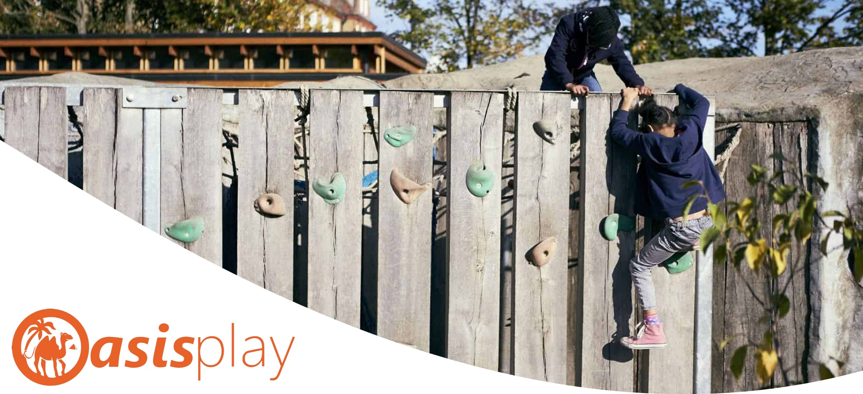
WERE
RECRUITING!
Forest School Leader role – Level 3
We are looking for an exceptional individual with a passion for outdoor learning and great work ethic. The role will include delivering a range of outdoor and indoor activities that enable each student to reach their full potential.
Part time working hours: 5.5hrs on Tuesdays, £14.50 per hour (1 x Forest School session, 2 hrs admin)
6hrs per week, £13 per hour — days TBC (2 x after school environmental play sessions)
Additional Senior Playworker support, as and when needed (£14.50ph) DEADLINE: ASAP

Playworker - 15 posts
We are looking for experienced, hard-working and enthusiastic playworkers. You will be working directly with disabled and non-disabled children and their families, supporting them to access the Oasisplay sites while facilitating exciting inclusive play opportunities.

Part time working hours vary: Term time - Tuesday to Friday: Up to 18.5 hours per week (after school club (3hrs per session) and Saturdays (6.5 hrs per session). Holiday time - Monday to Friday: Up to 32.5 hours per week (6.5 hrs per session). £13 p/h DEADLINE: ASAP - Rolling recruitment

Short Breaks Manager
We are looking for an experienced Short Breaks Manager to join the Oasisplay team. You will lead on the overall delivery of inclusive short breaks for disabled children and young people. Ensuring that children are effectively supported and that the service is run in a seamless and safe way.

Full time post Tuesday – Saturday 10-6pm (Monday – Friday Term time) 35hrs per week £33,000p/a DEADLINE 26th September 2021

Family Support Manager
We are looking for an effective leader to help improve the lives of families who access Oasisplay by providing a high quality, inclusive, family support service and ensure that children, young people and families are effectively supported through appropriate access to information, advice and guidance.

Part time post Tuesday – Saturday 10-6pm (Monday – Friday Term time) £33,000p/a pro rata £19,800 (actual salary) working 21 hours a week – days to be confirmed. DEADLINE 1st December 2021

Please download an application pack from our website www.oasisplay.org.uk or contact HR@oasisplay.org.uk

Please refer to the job description for full details and ensure your application reflects how you meet the required specification.

